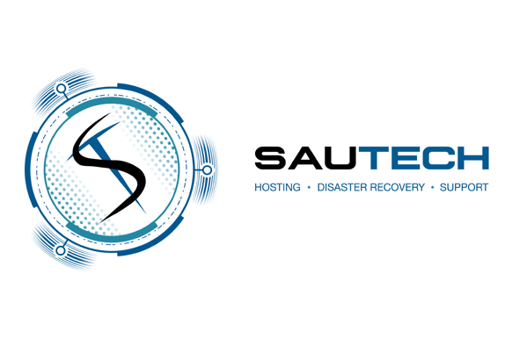


Company Profile


Introduction

Hosting history established in 2003, Sautech has grown from a hosting services entity, to a full managed services provider operating in three datacenters, two of which are in South Africa and one in Windhoek Namibia. Sautech has expanded its services to the Namibian Market in 2023.

We have extensive knowledge and experience in multiple projects, clients and technologies. As a security precaution, we do not list any client’s name or contact information.

Our main focus is disaster recovery, business continuity, cyber security, penetration testing and virtualization.

Our client base is anything from small businesses to blue chip organizational security and hosting that includes government entities and operations.

Sautech hosts and supports businesses throughout Africa and certain parts of Europe. Our next expansion would be into the United States of America.

Vision

Building on the pillars of quality service, strong partnerships, unwavering profes- sionalism, and superior knowledge of IT, Sautech is committed to delivering innova- tive and tailored technology solutions. With a customer-centric approach and a dedi- cation to excellence, we strive to be the IT Service Provider of choice throughout Southern Africa and Namibia, empowering businesses with cutting-edge technology and reliable support.

By understanding the unique challenges faced by modern enterprises, we provide scalable and future-ready solutions that drive efficiency, security, and growth.




Mission

Sautech specializes in the SME Industry. This industry is fractured and not being attended to professionally. The SME market is very demanding, the benefit is the comfort to execute.
The specialization is focused on our services and not our client-base. The design, implementation and configuration of all of Sautech solutions are flexible, reliable and reputable in the community.

Through professional services we aim to provide our customers with IT solutions that leverage only the best from the ever evolving and dynamic technology indus- try, distinguishing ourselves through our service ethic, delivery mechanisms and attention to detail.

Hosting

Managed Hosting

At Sautech, we are a trusted Managed Hosting and IT services provider, dedicated to overseeing and delivering a comprehensive range of hosting solutions. We take full responsibility for manag- ing critical IT infrastructure, proactively ensuring optimal performance, security, and reliability—so you can focus on growing your business while we handle the technical complexities.

- Our services cover essential aspects of hosting, including:

- Backups

- Updates

- Malware and virus protection

- Uptime monitoring

- Resource management

We specialize in Microsoft and Linux operating systems, integrating advanced security solutions such as firewalls and AI-driven Endpoint Protection (EPR) software to safeguard your digital assets.

Our Managed Hosting Services Include:

- Monthly server management – Updates, resource allocation, and performance monitoring

- Daily antivirus monitoring – Ensuring real-time virus protection and updates

- Weekly backup management – Regular monitoring and maintenance of backups

- User support – Assisting with hosting-related queries, connection issues, software updates, and application performance

- Quarterly backup testing – Scheduled sessions to verify backup integrity (included in support costs)

- Security and compliance – Implementation of standard security protocols and SSL recommendations

- Change management – Ensuring smooth transitions and system modifications
- User management – Creating, modifying, and controlling access for users With Sautech, you get a fully managed hosting solution that ensures reliability, security, and
seamless operation, allowing you to focus on what matters most—your clients and your business.


Physical Hosting

We offer dedicated hosting in three forms namely:

- Rack hosting
- Rented server
- Supply your own

Dedicated hosting is an internet hosting option in which a physical server hosting (or servers) is dedicated to a single business customer. The customer has complete control over the machine, so they can optimize it for their unique requirements, including performance and security. The hosting provider supplies the physical server and environment, the associated services and technical support.

Dedicated hosting is synonymous with dedicated hosting service, managed hosting service and dedicated server.


Virtual Hosting

Working with Virtual Server Hosting is similar to using dedicated servers, with all access and connectivity managed by Sautech. Your virtual server operates with the same reliability as dedi- cated infrastructure, providing secure and efficient access.

The advantage of Virtual Private Servers (VPS) is that it offers powerful computing resources at a more affordable price than dedicated servers. VPS also allows easy scaling, enabling you to adjust resources up or down based on your needs.

Sautech provides Virtual Server Hosting and Virtual Infrastructure Hardware, with the option to choose your preferred operating system, such as Microsoft Windows or Linux Distros, giving you a flexible and cost-effective solution for your business.

Disaster Recovery

Data is one of the most crucial assets of your business. While it’s important to protect your data today, it’s equally essential to plan for potential data loss scenarios. Disasters can range from minor data loss to the catastrophic loss of all data on an entire site.

Backups stored within the same site offer little value in the event of a disaster. It’s vital to have a system in place that replicates your production data to a secondary or disaster recovery (DR) location.

We offer reliable hosting services in South Africa and Namibia, including:

- Offsite data replication

- Full server backup

- Replication and always-on services Starting from: R1 per GB Storage.

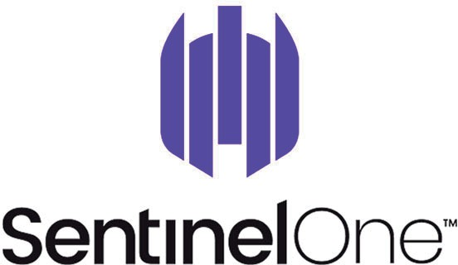

CYBER SECURITY

Sentinel One

The first cyber security AI platform to protect the entire enterprise.

Break down security silos. Gain enterprise-wide visibility and control. Action your data in real time with AI.

In the battle against ever-evolving cyber threats, we need to act faster and smarter than what’s possible with human-powered technology. SentinelOne is an autonomous cybersecurity, built for what’s next.

Sautech is an authorized partner of SentinelOne. We offer cloud managed solutions on Sen- tinelOne, so you are always monitored. This is a must have enterprise cyber security software for devices.

CheckPoint Firewall

Integrating the most advanced threat prevention and consolidated management, our security gateways are designed to prevent any cyber-attack, reduce complexity and lower your costs.

CheckPoint firewall software utilizes multiple technologies to inspect for the port, source, and destination rules, and also for application-level vulnerabilities. Using separate modules for the scans (e.g., Web, abnormal activity, and DoS), CheckPoint Firewall provides high throughput.

Sautech is a CheckPoint partner and together with Report Star offer the following:

- Device support
- Licensing
- Managed services and outsourced support

The above can be branch devices or hosted data centers instances.

Server and Infrastructure Optimization

Server and infrastructure optimization is a crucial aspect of maintaining an efficient and high performing IT environment. It involves the systematic enhancement of server hardware, software, and overall network infrastructure to maximize resource utilization, improve response times, and minimize downtime. By deploying various optimization techniques such as load balancing, virtual- ization and efficient storage solutions, organizations can ensure that their servers operate at peak efficiency while accommodating growing workloads. Sautech specializes in maintaining servers including Windows and Linux environments, Pastel and SQL

Sautech specializes in Maintaining Servers including Windows and Linux environments, Pastel and SQL implementations. Our Team performs Maintenance Services, Adhoc SLA Onsite and Remote Support.

Our Team focuses on a managed backup solution together with our Site24 Monitored services we are always one step ahead.

Penetration Testing

Penetration testing, also known as ethical hacking, is a proactive cybersecurity practice aimed at identifying vulnerabilities in systems, networks, or applications. Skilled professionals, known as penetration testers or ethical hackers, simulate real-world cyberattacks to find weaknesses that malicious actors might exploit. The goal is to uncover security flaws before attackers can take advantage of them, enabling organizations to strengthen their defenses.

- Penetration testing follows a systematic and controlled process, which includes:

- Reconnaissance

- Vulnerability analysis

- Exploitation

- Post-exploitation analysis

By conducting penetration tests, businesses gain valuable insights into potential security risks, helping them prioritize remediation efforts and enhance their overall cybersecurity. This proactive approach ensures the confidentiality, integrity, and availability of digital assets. Regular penetra- tion testing is a vital part of a comprehensive cybersecurity strategy in today’s ever-changing threat landscape.

We offer a straightforward, results-driven approach, led by our certified engineers. Our team provides actionable information and a “how-to” guide for implementing our findings and recom- mendations, further strengthening your security environment.

Ethical Hacking (White Hat)

The goal of ethical hacking is to simulate real-world cyber threats in order to help organizations strengthen their defenses against potential cyberattacks. Ethical hackers, or "white hat" hackers, use their skills to identify and fix vulnerabilities before malicious hackers can exploit them.

We focus on the following key areas:

Vulnerability Assessment:

Ethical hackers conduct thorough assessments of systems to identify potential vulnerabili ties. Using various tools and techniques, they analyze software, network configurations, and infrastructure components to find weaknesses.

Penetration Testing:

Ethical hackers perform controlled simulated attacks (penetration tests) to exploit identified vulnerabilities. This process helps organizations understand how their systems might be compromised, allowing them to address weaknesses before malicious hackers can take advantage of them.

Security Auditing:

Ethical hackers conduct comprehensive security audits to evaluate an organization’s overall security posture. They review policies, procedures, and configurations to ensure they align with industry best practices and compliance standards.

Social Engineering Testing:

Ethical hackers use social engineering techniques to test the human aspect of security. By attempting to manipulate individuals within the organization to gain access or extract sensitive information, they uncover weaknesses in employee awareness and training.

Security Patching and Remediation:

Ethical hackers work closely with organizations to develop and implement strategies for patching and remediation. After identifying vulnerabilities, they collaborate with IT and security teams to prioritize and address issues, ensuring security patches and measures are applied to mitigate risks.

Ethical hacking plays a vital role in strengthening an organization’s cybersecurity defenses, ensuring proactive protection against cyber threats.
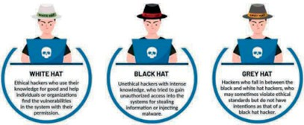

Internet Services

Hosted Exchange

Our Hosted Exchange solution is a fully managed Microsoft Exchange 2016/2019 secure and multi-tenanted solution delivered from the cloud. Our Exchange is supported by Microsoft, Check- point Security, Hosting Controller and SpamTitan. This environment is in-house supported by Sautech engineers. Sautech was one of the first to offer Hosted Exchange 2016 in South Africa.

BENEFITS:

- Always ON
- Calendar sharing
- Phone/Tablet/Laptop Synchronized email
- Backed-up in the Cloud

Sautech only offers our hosted exchange solution to resellers and selected clients. Our unique portal allows you, and MCP to deliver the support to your end customer.

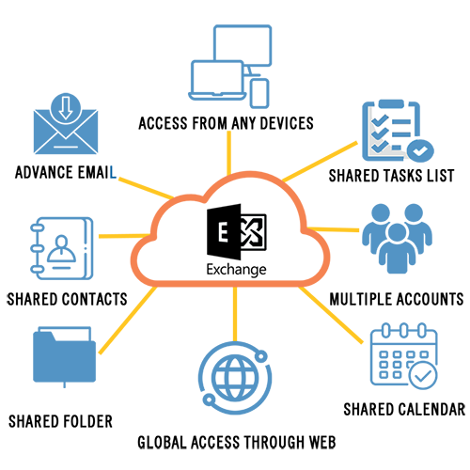

SD-WAN

Software-Defined Wide Area Networking (SD-WAN) offers numerous benefits for modern network infrastructures, including:

Enhanced Network Performance:

SD-WAN optimizes traffic routing over the most efficient path based on real-time condi tions, improving performance and reducing latency for a better user experience.

Cost Savings:

By leveraging cost-effective internet connections alongside traditional MPLS links, SD-WAN offers significant cost savings compared to traditional WAN architectures.

Increased Agility and Flexibility:

SD-WAN provides a centralized, programmable management interface that allows for quick adjustments to network policies, adapting to changing business needs.

Improved Security:

Advanced security features, such as encryption and segmentation, enhance network security, protecting sensitive data from cyber threats.

Application Optimization:

SD-WAN enables intelligent routing that prioritizes critical applications, ensuring optimal performance for bandwidth-intensive services like video conferencing and cloud applica tions.

Simplified Management:

Centralized management streamlines the administration of geographically dispersed networks, reducing complexity in managing multiple devices and configurations.

Quick Deployment and Scalability:

SD-WAN enables rapid deployment and scalable infrastructure, allowing organizations to expand their network efficiently, especially when opening new locations.

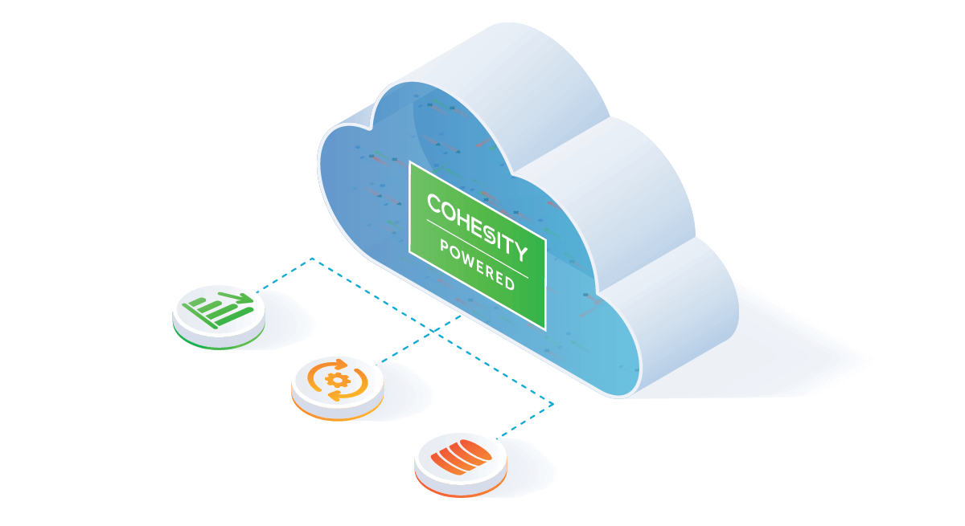
SauHost – Data Retention in Cloud

SauDrive allows you to manage centralized file sharing, space for backups, client documentation and project files,
stored securely in the cloud. Sautech manages your backups to an offsite location for continuity and disaster recovery.

Data is stored in the cloud, where all staff or clients (based on security settings) has access to:

User Based Backup

SauDrive is Sautech’s data sharing solution. With Sautech’s SauDrive, we take care of every- thing. Installing a fileserver, server support and data backups to external drives. These are all managed remotely, eliminating the need and cost of onsite IT support. Simply supply us with the users that needs to connect and we will setup your space and configuration. Your data is secure in the cloud. Our team is also available to assist you or your onsite IT support to configure the daily backups to our infrastructure. We also offer an outsourced backup managed service to maintain and test your offsite backups.

Centralized Storage Sharing: (SauFileShare)

SauHost data retention in cloud network sharing and centralized document management, can be hosted securely in the cloud for all employees to share, and utilize, either onsite or remotely.
Each client can setup his own security on all data, so that each employee or department can have their own unique access.

The SauFileShare option also has the option to allow you to back up your onsite servers and data securely to the cloud for compliance and disaster data recovery.
.


Reseller Hosting

Reseller hosting services offer entrepreneurs and businesses the opportunity to enter the web hosting industry without the need for extensive infrastructure or technical expertise. In this model, a company purchases hosting resources from a larger hosting provider and then resells them to its clients, often under its own brand.

Reseller hosting allows for the allocation of server space, bandwidth, and other resources to multiple clients, who can then host their websites or applications. This arrangement is particularly beneficial for web designers, developers, or small hosting businesses looking to offer hosting services without the overhead of managing and maintaining server infrastructure.

Reseller hosting providers typically handle server management, maintenance, and technical support, allowing resellers to focus on customer relationships and business growth. The flexibility and scalability of reseller hosting make it an attractive option for those seeking an entry point into the hosting industry while providing value-added services to their clientele.

We offer reseller hosting services in the following:

- Hosted exchange
- Penetration testing and ethical hacking
- Disaster recovery services
- SentinelOne
- Cyber security and infrastructure
- Hosting and virtualization infrastructure

There are various tiers of partners, please contact support@sautech.net for specific questions.
.

.

